# Browser

The browser will send a request (as a URL) to the HTTP server, via the Internet.

The browser will receive an HTML file and any another files from the HTTP server.

If HTML is received, the browser will convert each line of HTML into formatted output on the browser screen.

If the file is an image, Javascript or CSS, it should be used alongside the HTML when rendering the final page.

Tags in the HTML will determine what elements are on the page and CSS will determine how they will be positioned and what they’ll look like.

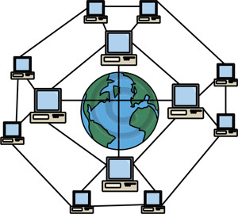

**Internet**

Find server location

Find user machine location

**Web Browser**



Create page request

Combine html and other files to render final web page

User types in URL, clicks on link or submits form

Request with server and resource



html, css, javascript, media or other file

Final rendered web page

**What you have to do**

To request a page from the HTTP server, complete the HTTP request and pass it to the Internet. Take the files you receive and put them together to create the finished page.

**GET** HTTP/1.1

**Host**: testserver.com

**GET** HTTP/1.1

**Host**: testserver.com

**GET** HTTP/1.1

**Host**: testserver.com

**GET** HTTP/1.1

**Host**: testserver.com

**GET** HTTP/1.1

**Host**: testserver.com

**GET** HTTP/1.1

**Host**: testserver.com

**GET** HTTP/1.1

**Host**: testserver.com

**GET** HTTP/1.1

**Host**: testserver.com

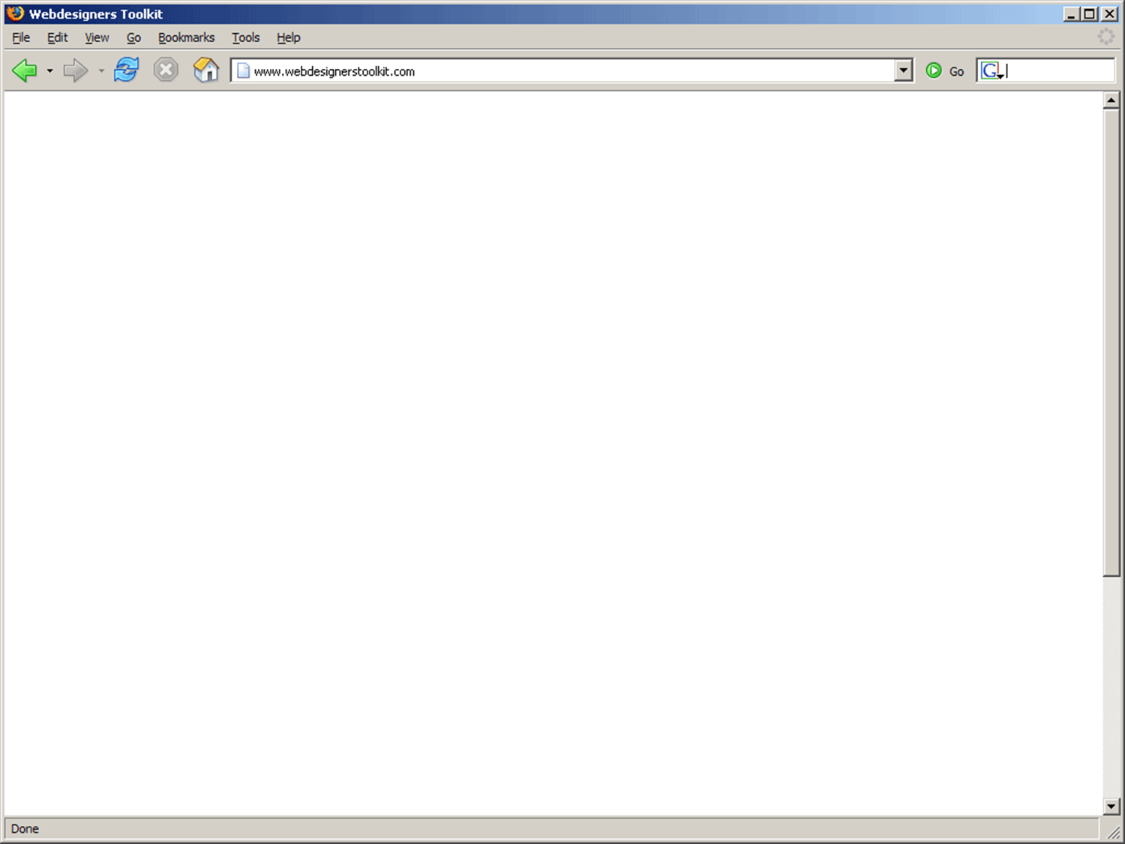

Internet

The Internet will take the request from the Browser to the HTTP server using the server address

The Internet will take the response from the HTTP server to the Browser using the return address of the users machine.



**Web Browser**

Create page request

Combine html and other files to render final web page



**Internet**

Find server location

Find user machine location



**HTTP Server**

Handle request. Find the resource on the http server

Decide if it needs further processing

Request with server and resource

Request with server and resource

html, css, javascript, media or other file

html, css, javascript, media or other file

**What you have to do**

Transfer the request from the web browser to the http server and then transfer the file from the http server back to the web browser.

# HTTP Server

The HTTP server handles requests sent from the browser (via the Internet) for files stored on the web server.

The HTTP server will send a response back to the browser, via the Internet.

Web page files and media files (like images and videos) will be located from the document store and sent to the browser.

Server-side scripts (such as PHP files) will be passed on to the server-side scripting engine to be processed. The server-side scripting language will pass this back to the HTTP server to be sent back to the browser.

URLs may include **parameters** stored as a name and value pair, such as id=4, after the resource location.



**HTTP Server**

Locate file in http document store

Send to scripting engine for further processing



**Internet**

Find server location

Find user machine location

Request for static file



**Scripting Engine**

combine html fragments with results of php instructions to create complete html file

html, css, javascript, media file

Request for server side script file

Server side script file

Fully processed html file

Fully processed html file

**What you have to do**

Locate the file and either pass it to the internet or if it’s a .php file pass it on to the scripting engine for further processing

**img/buynow.jpg img/sale.png**



**img/horse.jpg**

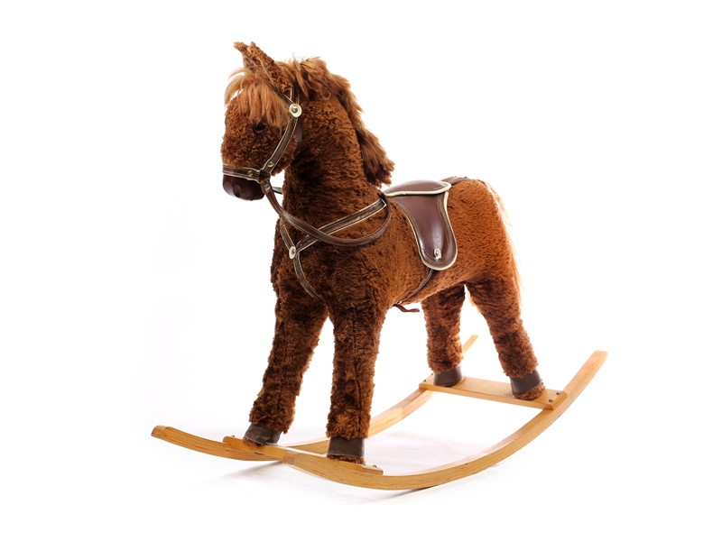

**img/loombands.jpg**



**img/skateboard.jpg**

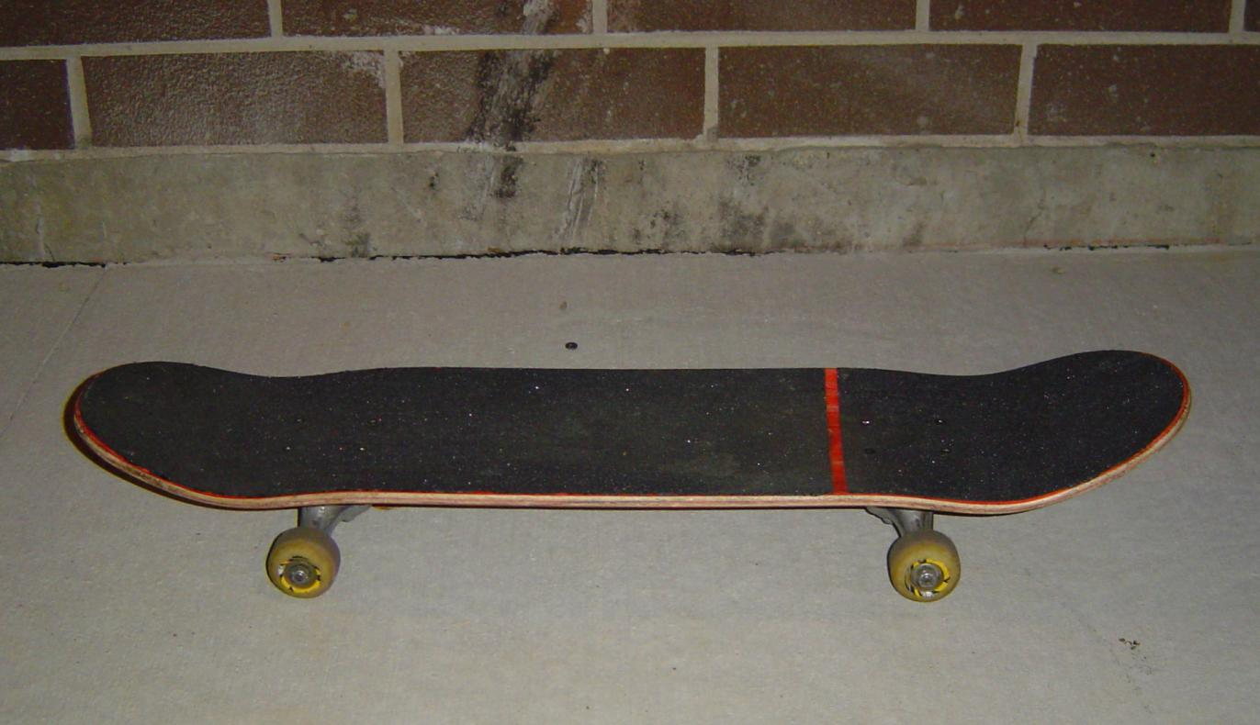

**img/watergun.jpg**

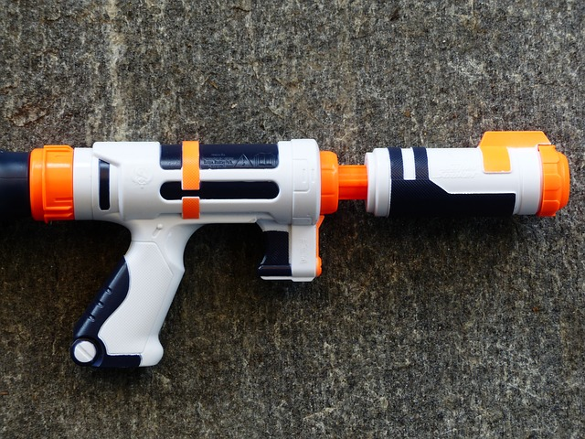

# Scripting Engine

The PHP scripting engine will receive the location of a PHP file on the server from the HTTP server.

The PHP scripting engine will evaluate blocks of PHP code and output HTML.

The request may contain data, which is stored in a variable called $_GET. This will include any parameters send with the URL.

To evaluate code, the PHP scripting engine should carry out calculations, comparisons or decisions.

The PHP scripting engine may have to connect to a database to request data. To do this, an SQL statement should be prepared and sent to the SQL server. It can then deal with the result.



**Scripting Engine**

combine html fragments with results of php code blocks to create complete html file

if database data needed create query to get data

add data to create complete html file



**Database Server**

Searches for matching records, or updates, deletes or amends information



**HTTP Server**

Send to scripting engine for further processing

Server side script file

Database query

SELECT * FROM table

S

Fully processed html file

Return result of query

**What you have to do**

You shouldsend a database query to the database server if there is one and then choose which complete HTML file would be the one generated by the php script and send it back to the http server.

**SQL Query**

**SQL Query**

**SQL Query**

**SQL Query**

Database Management System

The database management system will receive a query (such as SELECT) from the PHP scripting engine.

In a SELECT statement, the database management system will return a result set containing the rows that match the query.

The SELECT statement will specify which fields to use for matching records.

The database management system will send its result back to the PHP engine, which stores the result in a variable.



**DBMS**

Searches for matching records, or updates, deletes or amends information



**Scripting Engine**

if database data needed create query to get data

Combine data with other php results to create complete html page

Database query

SELECT * FROM table

S

Return result of query

**What you have to do**

When you receive a query from the Scripting Engine you should select the set of results that would be generated by that query and give them to the Scripting Engine.

**Database server table**

| **id** | **name** | **description** | **price** | **image** |  |
| --- | --- | --- | --- | --- | --- |
| 1 | Rocking Horse | Magical rocking horse | 40.00 | img/horse.jpg |  |
| 2 | Super splash gun | Mega soaking water gun | 11.00 | img/watergun.jpg |  |
| 3 | Loom bands | Lovely loom bands for making things with your pals | 5.50 | img/loombands.jpg |  |
| 4 | Skateboard | Cool skateboard for adventurous people! | 9.00 | img/skateboard.jpg |  |

**Database response for task four**

| **id** | **name** | **description** | **price** | **image** |  |
| --- | --- | --- | --- | --- | --- |
| 4 | Skateboard | Cool skateboard for adventurous people! | 9.00 | img/skateboard.jpg |  |
| 2 | Super splash gun | Mega soaking water gun | 11.00 | img/watergun.jpg |  |
| 3 | Loom bands | Lovely loom bands for making things with your pals | 5.50 | img/loombands.jpg |  |
| 1 | Rocking Horse | Magical rocking horse | 40.00 | img/horse.jpg |  |

**Database response for task four**

| **id** | **name** | **description** | **price** | **image** |  |
| --- | --- | --- | --- | --- | --- |
| 1 | Rocking Horse | Magical rocking horse | 40.00 | img/horse.jpg |  |
| 2 | Super splash gun | Mega soaking water gun | 11.00 | img/watergun.jpg |  |
| 3 | Loom bands | Lovely loom bands for making things with your pals | 5.50 | img/loombands.jpg |  |
| 4 | Skateboard | Cool skateboard for adventurous people! | 9.00 | img/skateboard.jpg |  |

**Database response for task four**

| **id** | **name** | **description** | **price** | **image** |  |
| --- | --- | --- | --- | --- | --- |
| 4 | Skateboard | Cool skateboard for adventurous people! | 9.00 | img/skateboard.jpg |  |

**Database response for task four**

| **id** | **name** | **description** | **image** |  |
| --- | --- | --- | --- | --- |
| 1 | Rocking Horse | Magical rocking horse | img/horse.jpg |  |
| 2 | Super splash gun | Mega soaking water gun | img/watergun.jpg |  |
| 3 | Loom bands | Lovely loom bands for making things with your pals | img/loombands.jpg |  |
| 4 | Skateboard | Cool skateboard for adventurous people! | img/skateboard.jpg |  |

**Database response for task five**

| **id** | **name** | **description** | **price** | **image** |  |
| --- | --- | --- | --- | --- | --- |
| 1 | Rocking Horse | Magical rocking horse | 40.00 | img/horse.jpg |  |
| 2 | Super splash gun | Mega soaking water gun | 11.00 | img/watergun.jpg |  |
| 3 | Loom bands | Lovely loom bands for making things with your pals | 5.50 | img/loombands.jpg |  |
| 4 | Skateboard | Cool skateboard for adventurous people! | 9.00 | img/skateboard.jpg |  |

**Database response for task five**

| **id** | **name** | **description** | **price** | **image** |  |
| --- | --- | --- | --- | --- | --- |
| 1 | Rocking Horse | Magical rocking horse | 40.00 | img/horse.jpg |  |
| 4 | Skateboard | Cool skateboard for adventurous people! | 9.00 | img/skateboard.jpg |  |

**Database response for task five**

| **id** | **name** | **description** | **price** | **image** |  |
| --- | --- | --- | --- | --- | --- |
| 1 | Rocking Horse | Magical rocking horse | 40.00 | img/horse.jpg |  |

**Database response for task five**

| **id** | **name** | **description** | **price** | **image** |  |
| --- | --- | --- | --- | --- | --- |
| 4 | Skateboard | Cool skateboard for adventurous people! | 9.00 | img/skateboard.jpg |  |

Coordinator

To make sure that your group carries out their role accurately when simulating different situations.

**Web Browser Role**



To request a page from the HTTP server, complete the HTTP request and pass it to the Internet. Take the files you receive and put them together to create the finished page.

**Internet Role**



Transfer the request from the web browser to the http server and then transfer the file from the http server back to the web browser.

**HTTP Server Role**



Locate the requested file and either pass it to the internet or if it’s a .php file pass it on to the scripting engine for further processing

**Scripting Engine Role**



You shouldsend a database query to the database server if there is one and then choose which complete HTML file would be the one generated by the php script and send it back to the http server.

**Database Role**



When you receive a query from the scripting engine you should select the set of results that would be generated by that query and give them to the scripting engine.

**What you have to do**

You shoulduse the descriptions above of what each part of the system should do to make sure each member of your group is doing the right thing in each task.

At the end of a task you should encourage the group to summarise the flow of information between different parts of the system.